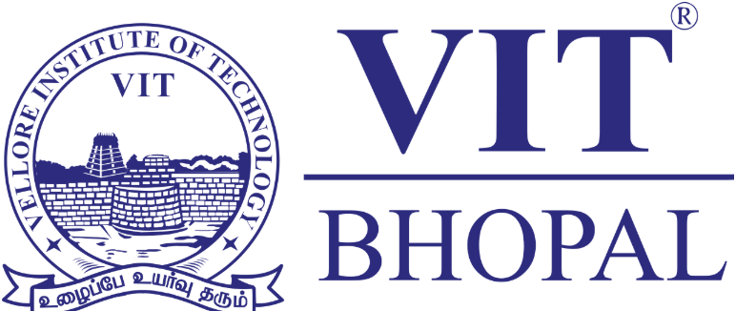

VITYARTHI PROJECT

DIGITAL LITERACY

NGMC COURSE

NAME: PARTH SURESH SHARMA
REGISTRATION NO.: 25BCE10005
DATE OF SUBMISSION: 31 MARCH 2026
COURSE: DIGITAL LITERACY
COURSE CODE: CSE0001
YEAR: FIRST YEAR

INTRODUCTION

The CSE0001 Digital Literacy project is a practical, 1-credit internal assessment designed for first-year B.Tech students across all branches. This project operates under a simulated professional scenario where the student is appointed as a Student Digital Ambassador. The primary objective is to build a comprehensive Digital Literacy Portfolio that demonstrates the ability to navigate the digital world, maintain professional online profiles, and communicate safely and responsibly.
The project is structured around five core modules, each requiring a specific deliverable to be organized within a single, public GitHub repository. These tasks include:
- Visual Resource Creation: Developing a digital literacy awareness infographic using design tools like Canva or Prezi.
- Professional Identity Building: Establishing foundational profiles on academic and professional platforms such as LinkedIn, GitHub, and Kaggle.
- Technical Tool Familiarization: Engaging with coding practice platforms like HackerRank or CodeChef and utilizing cloud collaboration tools like Google Workspace.
- Professional Communication: Drafting formal emails and establishing checklists for responsible social media conduct.
- Cybersecurity Awareness: Researching and documenting case studies on online threats and providing actionable prevention guides.
The final submission consists of the organized GitHub repository and a formal project report that documents the student's work, observations, and reflections across all five modules.

TASK 1: CREATING A DIGITAL LITERACY AWARNESS INFOGRAPHIC

Description:
I designed my infographic using Canva, starting with one of its templates and then customizing it to fit the theme of digital literacy. To make the visuals more engaging, I used Canva’s Magic Media tool to generate symbols that matched each section of the poster. The final design highlights four key areas: what digital literacy is, useful tools for students, building a professional online presence, and the importance of email and social media etiquette.
What stood out to me during the process was how helpful the Magic Media tool was in turning abstract ideas into clear visuals. For example, it’s easy to show platforms like Canva or LinkedIn with their logos, but concepts like “professional presence” or “etiquette” are harder to capture. Experimenting with generated icons and adjusting them to fit the layout was both challenging and fun. It made me realize that design isn’t just about decoration, it’s about finding creative ways to communicate ideas so they feel intuitive and accessible to the viewer.

TASK 2: DIGITAL PORTFOLIO

For this task, I chose to create accounts on GitHub, LinkedIn, and Kaggle because each platform serves a unique purpose in my academic and professional journey. GitHub is a space where I can share my coding projects, collaborate with others, and build a portfolio that reflects my growth as a programmer. LinkedIn helps me establish a professional presence, connect with peers and mentors, and showcase my education and achievements. Kaggle, on the other hand, is a community for data science and machine learning, where I can practice with real datasets, join competitions, and learn from others work.
Over the next four years, I plan to use GitHub to steadily upload my projects and learn version control through collaboration. LinkedIn will be my platform for networking, finding opportunities, and tracking my career progress. Kaggle will serve as a hands-on learning environment where I can challenge myself with practical problems and improve my analytical skills. Setting up these accounts was not just about completing a requirement—it felt like laying the foundation for my professional identity and growth in the digital world.

TASK 3: EXPLORING CODING & COLLABORATION PLATFORMS

For this activity, I worked with Google Forms and Google Sheets to build a small Digital Literacy Awareness Quiz for my batchmates. The form included five questions, mixing multiple choice and short answer formats, so that it could test both factual knowledge and personal reflections. Once the form was created, I linked it to a Google Sheet to automatically collect and organize responses. This gave me a clear view of how classmates engaged with the quiz and made the process feel more professional.

What I found valuable was practicing how these platforms connect and complement each other. Google Forms allowed me to design a simple but interactive quiz, while Google Sheets helped me manage the data in a structured way. Over the next four years, I see these tools becoming essential for academic work—whether it’s gathering feedback, running surveys, or analyzing results for projects and research. They make collaboration easier, save time, and help present information in a clear, organized format. Setting up this quiz wasn’t just about completing a task; it felt like learning practical skills that will support my studies and prepare me for more advanced digital projects.
TASK 4: DRAFT A PROFESSIONAL EMAIL & AND ETIQUETTE GUIDE

One situation where poor digital communication created a real problem was during a group project in college. The team used a messaging app to coordinate tasks, but one member sent unclear updates like “I’ll finish it soon” without specifying which part they were working on or when it would be done. This led to confusion, overlapping efforts, and ultimately a missed deadline because everyone assumed someone else was handling the critical section.

This issue could have been avoided with clearer, more structured communication. For example, the student could have stated exactly which task they were completing, shared a timeline, or used a shared document to track progress. Responsible digital communication means being specific, transparent, and considerate of how others rely on your updates. By practicing clarity and accountability, teamwork becomes smoother and deadlines are met more effectively.

TASK 5: CYBERCRIME AWARENESS CASE STUDY & PREVENTION GUIDE

What surprised me most while researching this topic was how easily small lapses in digital communication can escalate into major problems. Something as simple as a vague message, an unclear deadline, or sharing information without verification can create confusion, damage trust, or even lead to financial loss. I realized that digital literacy is not just about knowing the tools we use, but about being intentional and responsible in how we communicate online.

As a result, one habit I will personally change is to be more precise and thoughtful in my digital interactions. Whether it’s sending an email, posting on social media, or coordinating with classmates, I will make sure my messages are clear, respectful, and accurate. This small shift can help me avoid misunderstandings, build stronger professional relationships, and contribute to a healthier digital environment.

CONCLUSION

The CSE0001 Digital Literacy project concludes as a comprehensive evaluation of a student's ability to operate effectively within a professional digital environment. By fulfilling the role of a Student Digital Ambassador, the project transitions from theoretical knowledge to the creation of a permanent, live digital portfolio hosted on GitHub.
The successful completion of all five modules demonstrates a baseline proficiency in several critical areas:
- Visual Communication: The ability to translate complex digital concepts into accessible visual resources.
- Professional Identity: The establishment of a verifiable presence on industry-standard platforms like LinkedIn and GitHub.
- Technical Adaptability: Proficiency in using browser-based tools for coding, data collection, and cloud collaboration.
- Communication Standards: Mastery of professional email etiquette and the internalisation of responsible social media conduct.
- Digital Safety: The capacity to identify cyber threats and provide actionable safety guidelines for the academic community.
Ultimately, the project serves as a foundational requirement for first-year B.Tech students, ensuring they possess the essential digital skills necessary for their subsequent four years of technical education and future professional careers.

